Business Plan

Business Name:
Owner(s):
Date:

Website address:

Email address
TABLE OF CONTENTS
EXECUTIVE SUMMARY 2
OPERATIONAL PLAN 2
Business Description 3
Location 3
Management and Personnel 3
Owner’s Experience and Background 4
Legal Structure 4
Permits and Licenses 4
Accounting & Record Keeping 5
Insurance 5
MARKETING PLAN 5
Mission Statement 6
Market Needs 6
Target Market 6
Market Potential 6
Business Advisors 6
Marketing Outreach Plan 6
The Value of Competitors 8
Pricing Strategy 9
SWOT Analysis 9
FINANCIAL PLAN 9
Monthly Personal Budget Chart 10
Start-Up / Expansion Costs / Purchase List 11
Sources of Financing 12
Break-Even Point 14
Profit and Loss Statement 15
Cash Flow Projection 16

EXECUTIVE SUMMARY

The Executive Summary is a one page summary of the business plan.
Write the Executive Summary only after the rest of the plan has been written. The Executive Summary should be persuasive, compelling, and targeted to your audience. Hit on the high points of your business plan in a way that the reader will have a very good idea of what you do and how you will be successful.
It should include a paragraph for each of the following (also found within the business plan):
- Description of the business – What is the nature of your business and how are you meeting a need in the marketplace? What is your Unique Value Proposition (UVP)?
- Age of the business – How long have you been around, or when will your business launch? What is your experience?
- Products and services – Be clear about what you offer, and who you will sell to (consumers, organizations, businesses…)
- Competitive differentiation – What is your niche? What makes you different than the rest?
- Marketing goals – How will you reach customers?
- Sales and profit goals – What are your financial goals for the next year – sales (dollar amount and units sold), profit, etc.?
- Financing requirements – What type of financing is required, and how will it grow your business?

OPERATIONAL PLAN

Name of business:

Type of business:

Business Description
Choose what applies to your business and describe in detail. Delete what does not apply.
- Wholesale – Selling for resale. Describe the development of your product from raw materials to finished item.
- Retail – Selling directly to the consumer. Describe the products you sell and provide information about your suppliers. What is your system for managing or tracking inventory?
- Service – A retail business that deals in activities for the benefits of others. What is your service, who will be doing the work, and where will the service be performed?

Location
Address and telephone number of your business. Describe the space. Why does it make sense to locate your business there?

Management and Personnel
Who is involved in your business and what does each person do?
What is the background of each employee? What particular certification or training of each person in the business?

Owner’s Experience and Background
- Technical: What education, training, or experience have you had producing your product/service? Remember that experience in related or similar activities is important.

- Marketing/Sales: What education, training, or experience have you had in marketing or sales? Experience as a volunteer with your church, or other local civic or charity organizations is important.

- Financial: What education, training, or experience have you had managing finances? This includes balancing a checkbook, keeping books or files or preparing taxes, using Quickbooks or Excel.

- Planning/Organizing: What education, training, or experience have you had organizing people or projects? Activities for which you weren’t paid (like running a home, or volunteer) are important.

Legal Structure
Choose one below and delete the rest. Describe your reasons for choosing this particular structure.
- Sole Proprietorship | - Corporation (C Corp.)
- General Partnership | - Corporation (S Corp.)
- Limited Liability Company (LLC) | - Other

Permits and Licenses
List the permits or licenses you will need or currently have. Indicate if you already have the permits or license, and state the number of each.
- Occupational License
- Privilege License -- City and/or County (also known as Business License)
- Name Registration ABN or DBA _________________________
- Incorporation Papers Registry # ___________________________
- Sales Tax (WA Only)
- Employer ID # (Federal & State) EIN # ________________________
- Other

Accounting & Record Keeping
List the records that are necessary for you to keep. Describe your record keeping system. Are you using a software package? Ledger books? Please specify which system you are using, e.g. Quickbooks, etc. How often will you maintain your records – once per week? Once per month?

Insurance
Describe your business insurance needs. What policy do you have? What does it cover you from? Will you need additional coverage in the future?
If you do not have current business insurance, why not? At what point will you obtain insurance?

MARKETING PLAN

Mission Statement
1-2 sentences that describe the core purpose(s) of your business.

Market Needs
What benefits will your customers gain by using your products? What are you really selling? Why will your customers buy from you? What specific market need are you fulfilling? What has your focus group told you from Foundations?

Target Market
Give an overview of demographics of key target markets – income, age, gender, geography, family status, ethnicity, etc. What are their habits? Why type of clientele will become paying customers?
Be sure to include research, facts and figures in this section.

Market Potential
Describe the size and scope of your target market. What are your numbers for your industry as a whole? What are your industry numbers for your demographic and area? If you are a location based business, what is the population of your neighborhood/city/county? What percentage of people in your area do you expect to convert into customers?
Be sure to include research, facts and figures in this section.

Business Advisors
List out any advisors, business counseling or other resources you have accessed.

Marketing Outreach Plan
A marketing plan does not need to be expensive or sophisticated. It just needs to be an action oriented plan! It’s good to look at your marketing activities in 3 month increments. (Not all of your efforts will pay off in 3 months, and may stay on the plan longer). It is also important that you have different ways and strategies to reach your target market, which is why there are 3 categories below.
For the next 3 months, determine the activities in these marketing categories. Make sure that you know how you will measure the effectiveness of each activity at the end of 3 months. (For example, # hits on a social media site, sales from a networking event, etc.)
Online/Social Media
What | Frequency | How to measure | Cost
Google Ads/AdSense | Per click per day cost | Number of new patients or inquiries/month from ad | $5 - $20/day

People/Networking
What | Frequency | How to measure | Cost
Networking group | 1 per month | Number of interactions and demographics collected | $100 per annual membership
Free Library Talks | 1 per quarter | Demographics collected | $0

Other Promotion and Publicity
What | Frequency | How to measure | Cost
Direct mailings | Per month | New Pt. encounters/mailing | $0.46 per letter – avg $12 per month

The Value of Competitors
Use this worksheet to evaluate your competition. Summarize the information in text form.
Name | Your Business  Name Here | Competitor 1  (Insert Name) | Competitor2  (Insert Name) | Competitor3  (Insert Name)
Location
Quality
Range or type of services
Price
How they market
Target market
Other things you’ve learned about how you compare to your competition
Customer service

Pricing Strategy
What is your pricing structure? Give the business logic behind the decision, and answer the following questions:
- Does it match your image, how you want your product to be perceived?
- How does it compare to your competitors?
- Does it match your target market?
- Does it match demand?

SWOT Analysis
A SWOT analysis examines your Strengths, Weaknesses, Opportunities and Threats.
Strengths and Weaknesses are internal to you and the organization.
Opportunities and Threats are external to your business.
- List your strengths as a business owner, and the strengths of your business.
- List your weaknesses as a business owner and the weaknesses of your business.
- What business opportunities are available for your business?
- What threats in the external environment does your business face? A new competitor coming in, new regulations, an economic slump, etc.

FINANCIAL PLAN

Monthly Personal Budget Chart
Customize to your particular needs and business. These are examples of subcategories. Your business income should reflect what you personally draw from the business for income/pay and is not the same as your business sales.

Monthly
Totals
Income
Salary or wages | $
Business income | $
Total Incoming
Expenses
Rent
Utilities
Phone
Gas/Electric
Water
Garbage
Credit card payments
Food
Groceries
Dining out
Entertainment
Home/renters insurance
Health insurance
Loan payment
Student Loan
Other Loan
Taxes
Total expenses | $

Start-Up / Expansion Costs / Purchase List
List the items you need to purchase to open your doors for the first time, or what is necessary for your next stage of business growth. Customize this worksheet to meet your particular business’s needs—these are only suggestions. It is helpful to show a subtotal for each category.
Please provide a duplicate list for items you have already purchased for your business.
Category  (Examples) | Item | Qty | Where will you buy? | Cost | New or used? | Total Cost | Purchased?  (Y/N)
Furniture
Licenses
Office supplies
Inventory
Equipment
Other
 |  |  |  |  |  | Total

Sources of Financing
Indicate where you will get the money to finance your business.
Source | Investment | Loan
Personal Savings
Relatives
Friends
Loan
Others
Total (must equal or exceed total start-up costs)

List the names, addresses, and phone numbers of your investors.
Overhead Business Costs
List the monthly expenses you incur regardless of what your monthly sales are (also referred to as “fixed costs”). Customize this sheet to meet your individual needs.
Expenses
Rent
Utilities
Phone/internet
Gas/Electric
Water
Garbage
Automobile (for work)
Gas
Insurance
Maintenance/repair
Home/renters insurance
Health insurance
Loan payment
Taxes
Promotion
Professional fees (legal or accounting)
Office Supplies
Repair / Maintenance
Misc. expense
Total expenses

Break-Even Point
This will show you how many units you need to sell to cover your costs.
Complete this analysis for each unit you sell.

Line | Break Even Point
1 | OH monthly cost
2 | Gross Profit per unit
3 | Break Even Point (line 1 divided by line 2)

Line | Gross Profit | $
1 | Price of one sales unit (what your customers pay)
2 | Cost of one sales unit
3 | Gross Profit per unit (Line 1 minus line 2)

Profit and Loss Statement
Please use the template found at this link: http://www.mercycorpsnw.org/docs/PL_Cashflow.xls
It is an excel worksheet that will guide you through the process of inputting sales and expenses. It will automatically pre-populate information on your Business Cash Flow.
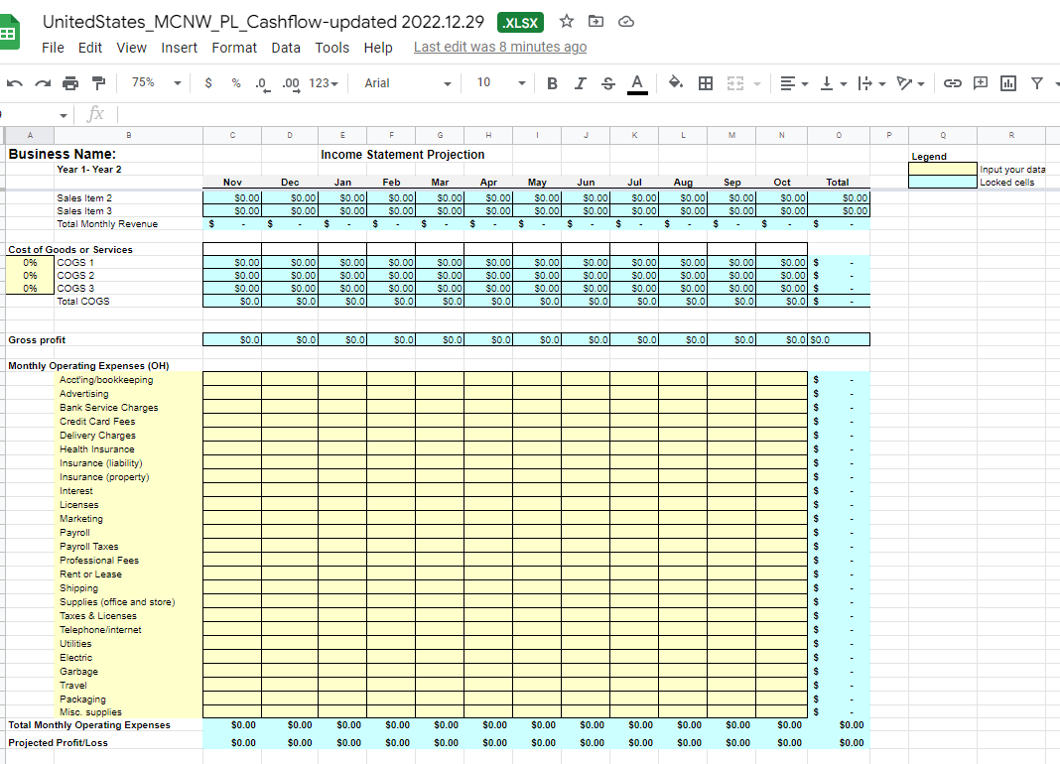

Cash Flow Projection
An excel worksheet with formulas is on the web: http://www.mercycorpsnw.org/docs/Personal_Cashflow-1.xls
The information you input into the Profit and Loss Statement will automatically populate this form.
